Lab 7: Dependency Injection in Blazor

Objective:
This lab aims to help students understand and implement dependency injection (DI) in Blazor applications. By the end of this lab, students will be able to:
- Understand Dependency Injection (DI) in Blazor.
- Register and inject services in Blazor components.
- Differentiate between Scoped and Singleton services.
Introduction to Dependency Injection in Blazor
Dependency Injection (DI) is a technique used in Blazor to provide objects (services) to components and other services, making the application modular and maintainable.
Example 1: Basic Dependency Injection in Blazor
- Create a new service TimeService.cs to provide the current time.
- Register the service in Program.cs.
- Inject and use the service in a Blazor component.
Step 1: Create a Service (Services/TimeService.cs)
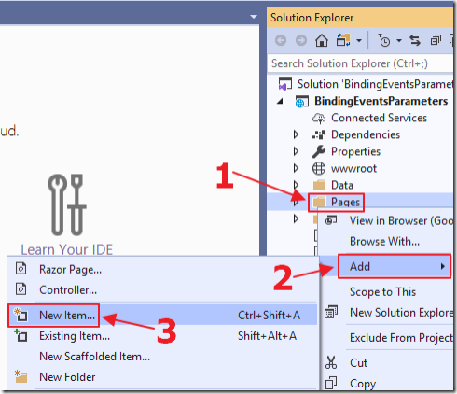
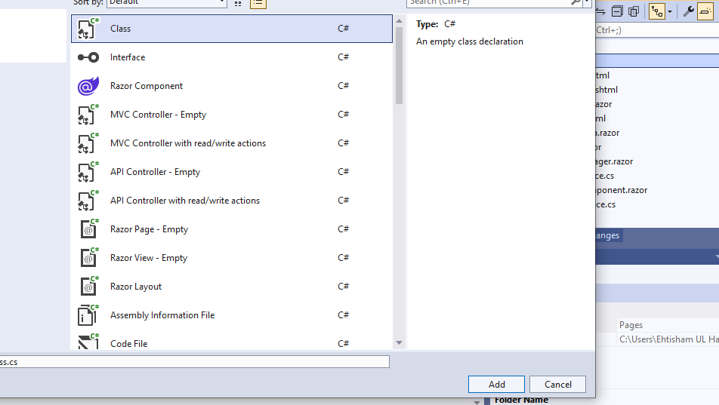
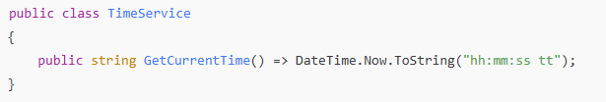
Step 2: Register the Service (Program.cs)
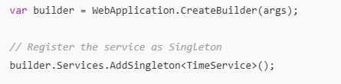
Step 3: Inject and Use the Service in a Blazor Component (Pages/TimeComponent.razor)
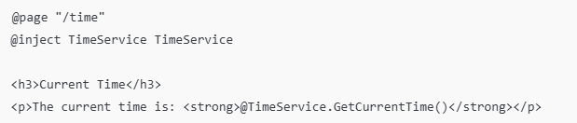
Run the program and check the output
Registering and Injecting Services in Blazor
Blazor supports three types of service lifetimes:
- Singleton – A single instance is shared throughout the application.
- Scoped – A new instance is created per user session.
- Transient – A new instance is created every time the service is requested.

Example 2: Registering and Injecting a Scoped Service
In this example, we will create a scoped service that generates a unique ID for each user session.
Step 1: Create a Scoped Service (Services/SessionService.cs)
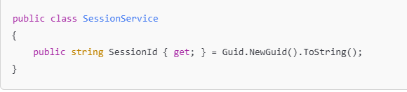
Step 2: Register the Service as Scoped (Program.cs)
Step 3: Inject and Use the Service in a Blazor Component (Pages/SessionComponent.razor)
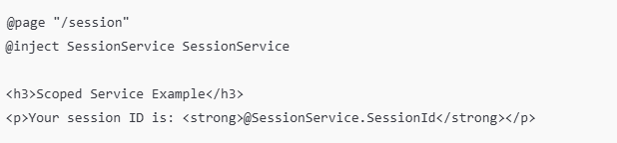
Since this service is scoped, the session ID remains the same throughout the user’s session but changes if the page is refreshed.
Scoped vs Singleton Services in Blazor
Example 3: Demonstrating Singleton vs Scoped Behavior
We will modify the previous example to compare singleton and scoped services.
Just change the services time from above example to AddSingleton
You can see that The Singleton Service ID remains the same, even after a refresh.
Singleton services share the same instance across the whole application.
Scoped services create a new instance per user session.

Lab Tasks:
Task1: Create a Salary Calculation Service that:
- Takes an employee's basic salary as input.
- Calculates deductions (e.g., tax, insurance).
- Computes allowances (e.g., bonuses, benefits).
- Determines the net salary after deductions and allowances.
Register the service in Program.cs and inject it into a Blazor component.
Create a Blazor component that:
- Accepts user input for the basic salary.
- Displays the calculated deductions, allowances, and net salary.
- Updates the results dynamically when the salary input changes.
Task 2: Create a Blazor Server App. Create a service that manages a list of elements. The service should support the following operations:
- Add a new element to the list.
- Edit an existing element.
- Delete an element.
- Search for a specific element.
Register the service in Program.cs.
Create a Blazor component that:
- Displays the list of elements.
- Provides input fields and buttons for adding, editing, and deleting elements.
- Includes a search function to filter elements based on user input.
Test the application by adding, editing, deleting, and searching elements in the list.

